Title Page
Course: CO2 - Algorithm Analysis and Design
Assessment: AT2
Question No: 7
Title: Brute-Force Approach to Find the Farthest Pair of Delivery Points
Name: ____ARCHANA DEVI.P_______________
Register Number: _____192521192______________
Department: Information Technology
Date: ______29.07.2026_____________

1. Aim
To identify the farthest pair of delivery points using the brute-force approach by calculating the Euclidean distance between every possible pair of coordinates.

2. Problem Statement
A navigation system processes the coordinates of multiple delivery points to determine the farthest pair of locations for route planning. The brute-force approach computes the distance between every possible pair and identifies the pair with the maximum distance.

3. Algorithm
- Read the number of delivery points.
- Input the coordinates of all points.
- Initialize the maximum distance to zero.
- Compare every point with every other point.
- Compute the Euclidean distance between each pair.
- Update the maximum distance whenever a larger distance is found.
- Display the farthest pair of points and the maximum distance.

4.Source code
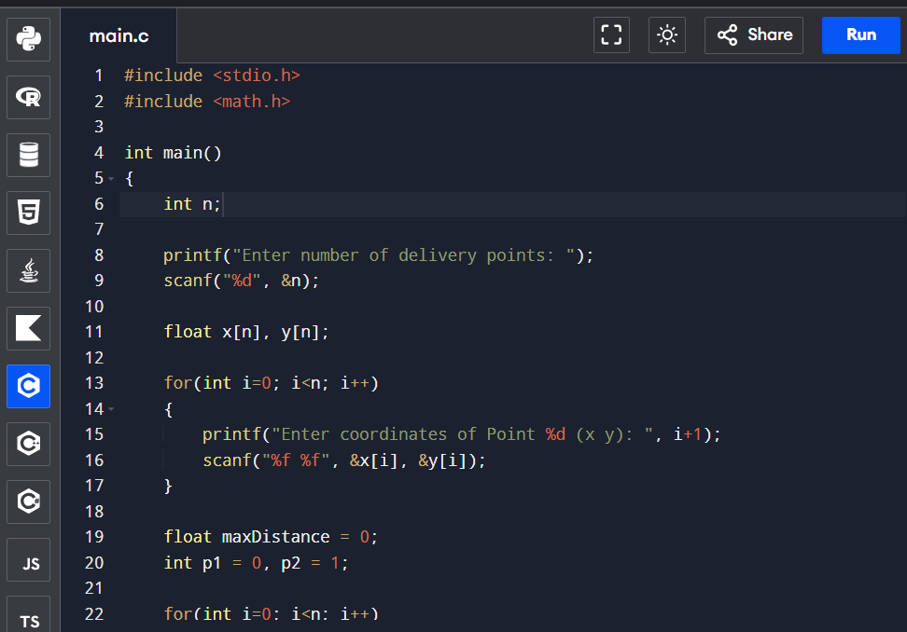
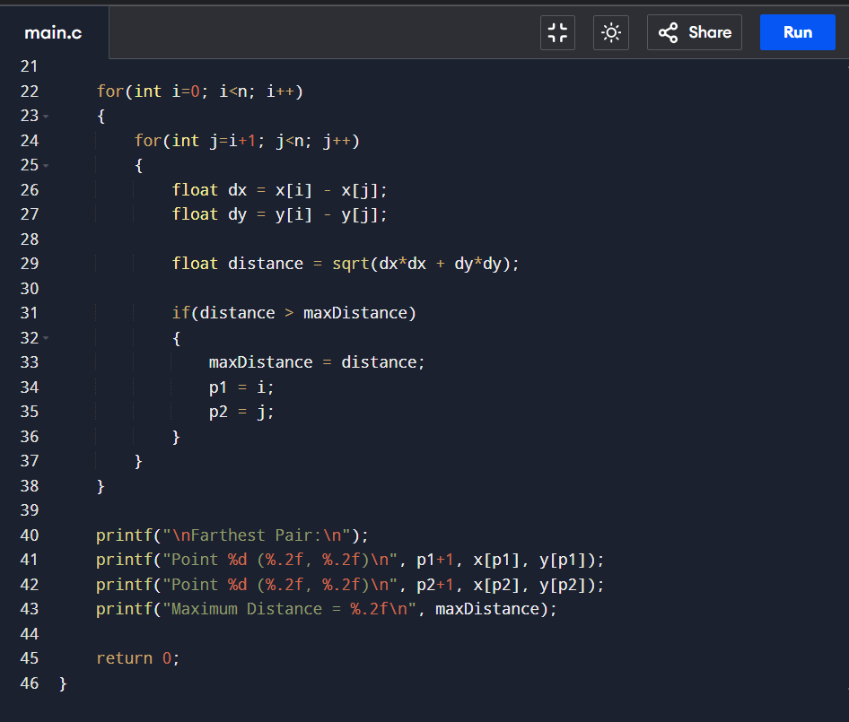

5. Execution Output



6. Time Complexity Analysis
Let the number of delivery points be n.
The algorithm compares every possible pair of points.
Number of comparisons:
$$\frac{n\left(n-1\right)}{2}$$
Each distance calculation requires constant time O(1).
Therefore,
Time Complexity = O(n²)
This quadratic complexity means the execution time increases rapidly as the number of delivery points increases.

7. Space Complexity Analysis
The algorithm stores the x and y coordinates of all points.
Storage required:
- x array → O(n)
- y array → O(n)
- Other variables → O(1)
Overall,
Space Complexity = O(n)

8. Result
The brute-force algorithm successfully identifies the farthest pair of delivery points by computing the Euclidean distance between every possible pair of coordinates.

9. Conclusion
The brute-force method is simple to implement and guarantees the correct solution by checking every possible pair of points. However, since it has a time complexity of O(n²), it becomes inefficient for large datasets. More advanced algorithms are preferred for handling large numbers of delivery points in real-time navigation systems.

